**Background**

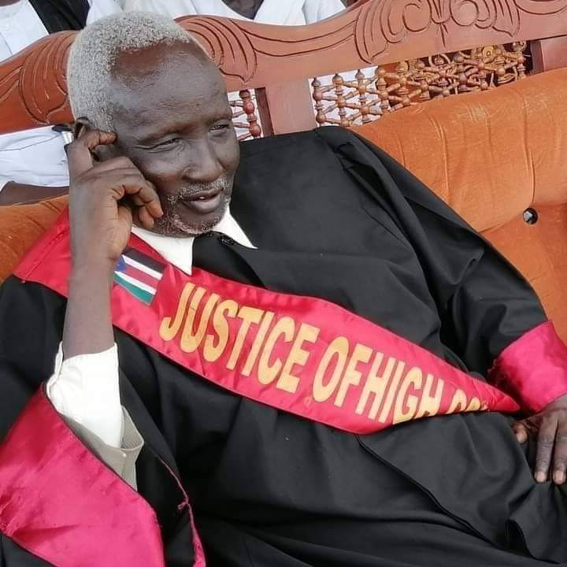Akurmic Law House ( ALH) is a professional law firm in Juba, the Republic of South Sudan existing in the private legal Practice since 1987. The chamber was first established in Khartoum, Sudan by Justice Mareu D. Malual-Akumric in 1987 and later in 1990, the founding partner joined public prosecution and risen to the overall Director of Public Prosecution in Upper Nile Region of the then Southern Sudan. Thereafter, he was appointed a state minister in Jonglei State in the Sudan. In 2003 Justice Mareu joined the Judiciary as 1st Grade Magistrate and died the President of the High Court of the Republic of South Sudan in 2020. The Law firm is now being managed by 2nd and 3rd Generation of Lawyers of Malual-Akumric Family.

The law firm continued to be operational through main partners in the persons of Adv. Reech M. D. Malual-Akumric, LLB, LLM (UoJ) LLP (SSBA) as Managing Partner and Adv. Amin M. Malual-Akumric, LLB (Nileen University) LLP (SSBA) as Senior Partner.

Akumric Law House stands a leading law firm in the Republic of South Sudan with both local, and regional influence in Eastern Africa.

Akumric Law House grips and advises clients on a range of fields including but limited to; Oil and Gas, Mining, not for profit organization (National and International), telecoms and media amongst government special projects. The Chamber delivers specialized legal services to corporate, government and not for profit entities in different fields of the law as Commercial Law, oil and gas law, taxation and employment law, investment law, alternative dispute resolution (Lobby, mediation, negotiation and Arbitration) and litigation in both civil and criminal matters. The chamber has a range of expertise in real estate, legal drafting of opinions, bills, and constitutions amongst others. Akumric Legal enjoys experience of public relations for its clients in which the department of PR and Litigation is led by Adv. Reech M.D. Malual, with extended experience in PR and Media as well as civil and criminal litigation.

### **Team & Management of the Law House**

### **Team & Management**

### **Head of PR and ADR**

Adv. Reech M. D. Malual-Akumric, LLB, LLM, LP

### **Head of Litigation and Practice**

Adv. Wol D. A. Chan, LLB, LLM, LLM, LP

### **Head of Oil and Gas**

Adv. Bol Madut Ayii, LLB, LLM, LLM, LP

### **Head of contracts**

Adv. Amin M. Malual-Akumric, LLB, LP

### **Lead Associate** Adv. Kuany Thiik, LLB, LP

### **Tributes**

Akumric Law House is an exceptional law chamber that serves their clients with special attention being vested professional services that ethically oriented with the Republic of South Sudan and in coordination with other lawyers and law firms within the country and or else outside the Republic of South Sudan. They show care and hence when stacked elsewhere it is advisable that you seek the attention of the ALH Advocates as a last resort to find a lasting solution to any legal matter of concern. Akumric Law House enjoys great PR with government institutions and regulators thereof. Adv. Reech M. D. Malual-Akumric has excellent communications and public relations skills, earning a reputation for excellent client management.

### **Main Legal Services**

* Alternative Dispute Resolution
* Tax Advisory
* Employment and Labour advisory
* Civil Litigation
* Criminal Litigation
* Legal Drafting
* Media law advisory
* Humanitarian and Public law
* Banking law advisory
* Commercial advisory
* Public Relations and Lobby
* Oil and Gas

### **Main Clients**

* Gourmet Services Co. ltd
* Specialist services Ltd
* Easy Services Co. Ltd (ESICO)
* Trinity Energy
* UNESCO-South Sudan
* UNDP- South Sudan
* Defy Hate Now - East Africa
* Yo’Care South Sudan
* Screen of Rights
* Rak Media
* MGurush

## Akumric LAW HOUSE

Akumric Law House is Highly regarded as one of the Republic of South Sudan’s big time law chamber, full service corporate and commercial firm and a leading national livewire based in Juba.

The Chamber’s consolidated and all-in-one legal services are offered to different clients in a professional and ethical manner by a diverse and talented team of four partners and over five associates based in our Juba’s offices, the Republic of South Sudan. Our lawyers have wide-ranged expertise and profound knowledge of the South Sudanese market, which optimally positions them to provide pragmatic advice to clients navigating the national scenery.

The firm has extensive experiences in management and handling legal matters in oil and gas, financial transactions, media technology and hospitality amongst other commercial transactions.

Akumric Law House is nationally recognized in the Republic of South Sudan as one of the leading law firms that delivers a viable client based legal services indiscriminately. It is formerly also known as the Ancestral Advocates.

## LAWYER PROFILES

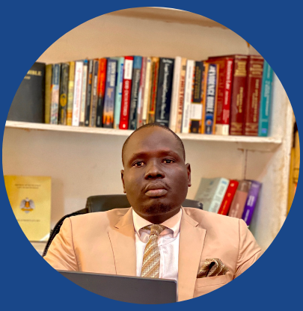Ad. Malual, LLB, LLM, LP is licensed with South Sudan Bar Association to Practice before all courts of the Republic of South Sudan, he enjoys over ten years’ experience in legal practice, human rights advocacy, broadcast and Print Media, UN experience, a fellow with the US Institute of Peace and Young African Leader of 2023. He is an expert in employment, Oil and Gas, Media, and constitutional Law.

Adv. Reech M.D. Malual, LLB, LLM, LLP Managing Partner

**Awards:** Winner of Poet Award, Wayne State University, USA 2023. Winner for Spirit of Detroit leadership Award, Detroit Michigan, USA 2023

A journalist, Lawyer, Poet, and Author to Bees Darling, King in the Dark, Queen of the Jungle and Facing Lucifer. Reech enjoys over fifteen (15) years’ experience in Journalism and Legal Practice in the Republic of South Sudan and East Africa. Adv. Reech pursues a PhD in Law with Parul University, India.

**LEGAL CONSULTANCIES & PRACTICE**

* Managing Partner, The Ancestral Advocates (TAA) | November 2018- present
* Chairperson, Coalition of Public Interest Litigants in South Sudan (CPIL-SOUTH SUDAN), 2019- to present
* Constant on GBV, UNDP-South Sudan, 2021
* Consultant on Data Protection Bill 2020, UNESCO-South Sudan, 2020 -2022
* Senior Partner/Advocate & Legal Consultant for Badri and Associates; 2015-2018
* Managing Partner, Akumric Law House
* Managing Partner, The Ancestral Advocates, 2018 - present
* Senior Partner, Badri Law Africa 2017
* Consultant, East Africa Law Society, 2021
* National Coordinator, IGAD South Sudan 2023 – present
* Consultant, Journalists for Human Rights, 2019
* Consultant, South Sudan Media Authority, 2019
* Deputy Spokesperson, South Sudan Bar Association – 2017 –2024

**MEDIA EXPERIENCE**

* Radio Journalist / Radio Miraya / Fondation Hirondelle & United Nations Mission in South Sudan (UNMISS) Juba and Bentiu-Unity state: January 2012 to June 2015
* TV Station Manager, Citizen Television CTV [South Sudan]/Juba, June 2015 - August 2016
* Managing Editor, The Business Focus Newspaper/Juba, South Sudan; September 2015 to January 2016
* Media Legal Consultant at Homeland International Recruitment & Consultancy Agency (HIRACA); Juba, South Sudan, February 2016 to January 2017
* Consultant/Concept Developer/Documentation, Subcommittee on Refugees & International Outreach, National Dialogue Initiative/ Juba, South Sudan, June 2017 to 2019

**FELLOWSHIPS**

* Generation Change Fellow, United States Institute of Peace, Washington DC, USA
* Young African Leader, Mandella Washington Fellowship for Young African Leaders (YALI)

**LEADERSHIP EXPERIENCE**

* Deputy Spokesperson, South Sudan Bar Association 2017-2024
* Chairperson, Coalition of Public Interest Litigants in South Sudan (CPILˇSUOUTH SUDAN)
* Former Secretary General, School of Law Students Association, University of Juba- 2013-2014
* Elected Chairperson, Ajuong Youth Association 2019
* Chairperson, Upper Nile Region Youth Union’s Electoral Committee, 2021

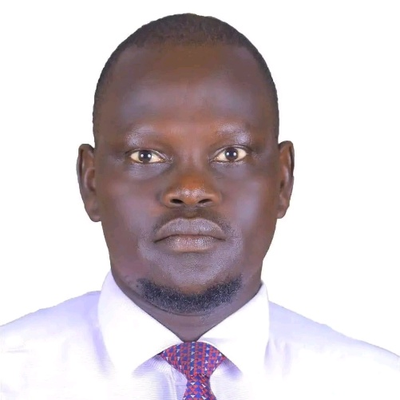Adv. Deng is a criminal litigation expert with African and Indian legal experience for over 12 years, he holds LLB and LLM from both Juba and Lucknow and a license of Legal Practice from the South Sudan Bar Association. He is a commissioner for Oaths.

He is an expert in taxation, civil and criminal litigation amongst others.

Wol currently sits on the Central Committee of the South Sudan Bar Association (SSBA).

Adv. Wol Deng Akech, LLB, LLM, LLP Commissioner for Oaths, Partner

Adv. Akech brings to Akumric Law House a rich and extended legal experience from both India and the Republic of South Sudan as he is a law lecturer with several universities in the Country.

Wol has served several law firms in the country including but not limited to Garang & Co. Advocates with a registered line of law practice success and client accumulative trust.

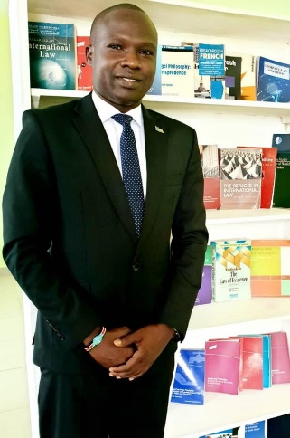**Adv. Bol** holds two LLMs from Both Juba and Nairobi and has extended expertise in oil and gas amongst other areas of the law.

Madut is a successful career inhouse Counsel with extended expertise in oil and Gas, Labour, legal drafting civil and Criminal litigation.

Ayii is licensed with the South Sudan Bar Association (SSBA) since 2017 and has been practicing Law with the Ancestral Advocates as a senior Partner and Inhouse Counseling.

Adv. Bol Madut Ayii, LLB, LLM, LLM, LLP (UoJ/UoN/SSBA) Partner

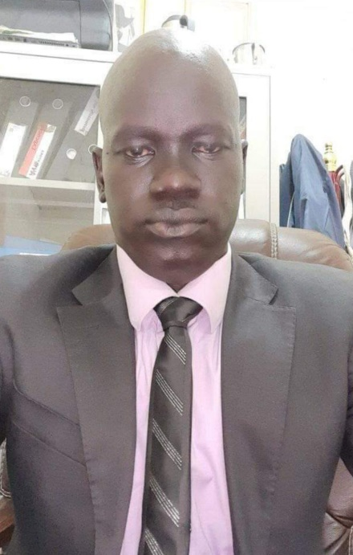Adv. Amin holds LLB from Nileen University of the Sudan and a license of legal Practice from South Sudan Bar Association (SSBA). He has practiced law for over fifteen years with expertise interest in contracts, procurement law, Civil and criminal litigation.

Adv. Amin Majok Malual, LLB, LLP (Nileen/SSBA) Partner

Adv. Malual Manages a Branch of Akumric Law House in Malakia, Konyokonyo Road and he is the 2nd generation of lawyers for Akumric Family.

Adv. Majok has been practicing law for most of his life since graduation from law School and hence holds a great deal of experience and a client trust base.

## Associates

ALH enjoys range (20) of associates equipped to serve in the legal practice of the Republic of South Sudan and East Africa.

## MAIN CONTACTS

|  |  |  |  |
| --- | --- | --- | --- |
| Department | Name | Email | Telephone |
| Managing Partner | Reech Malual | [akumriclawhouse@gmail.com](mailto:akumriclawhouse@gmail.com)  [rmalual@gmail.com](mailto:rmalual@gmail.com) | +211920077727  +211918193218 |

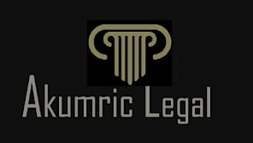**PHYSICAL ADDRESS**

2nd Floor, Chan House, Opp. University of Juba, Atlabara Campus

Juba, The Republic of South Sudan |Akumric Law House, formerly the Ancestral Advocates